Chapter 9, Problem 38.

Using Fig. 9.45, design a problem to help other students better understand admittance.

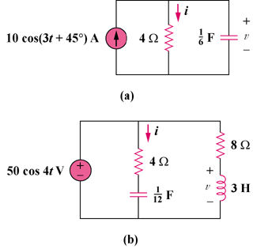
R
i_{S}(t)
C
v_{S}(t)
R₂
R₁
L
C

Figure 9.45
For Prob. 9.38.

